**Learn Site Requirements**

**February 10, 2016**

**Video, Brands, Products & Services, Customer Support, Media**



CTA

Sub Header

Header

|  |  |  |  |
| --- | --- | --- | --- |
| **Req #** | **Breakpoint** | **Requirement** | **Notes** |
| Video Module | | | |
| 1 | Desktop | This Div container consists of a header, sub header, video, CTA, and a background image. Play icon (PNG) needs to be displayed over background image. Image will be delivered via Vidyard. | The background image will match what is specified in the video player (Vidyard) |
| 2 | Desktop | Ability for the video to play on screen, as a lightbox or link to another page that contains a video |  |
| 3 | Tablet | Same Requirements as Desktop (HTML 5 Video) |  |
| 4 | Mobile | When video is clicked open helper app to expand video to mobile size (HTML 5 Video) |  |



CTA

Image

Sub Header

Header

|  |  |  |  |
| --- | --- | --- | --- |
| **Req #** | **Breakpoint** | **Requirement** | **Notes** |
| Brands Module | | | |
| 1 | Desktop | Div container consists of a header, sub header, carousel and a CTA. Ability to display a minimum 5 images at a time, and a maximum of 15 in the carousel | -Only 5 images at a time can be displayed. When navigation carrot is clicked the far left image disappears and the next image displays on the far right (scrolls one image at a time)  -When more than 5 images are available in the carousel, right and left navigation carrots appear. |
| 2 | Desktop | Ability for images to be clickable in order to link to a new page. Ability to open in new window, same window, different file types (pdf, video, jpg, HTML) | Images should be built using replicants. |
| 3 | Tablet | Same requirements as Desktop excluding navigation carrots | Swipe navigation |
|  | Tablet | Ability to tap image to link to another page |  |
| 4 | Mobile | Header, sub header, carousel and two small images in portrait view and three in landscape view with same navigation functionality as tablet |  |
| 5 | Mobile | Ability to tap image to link to another page |  |

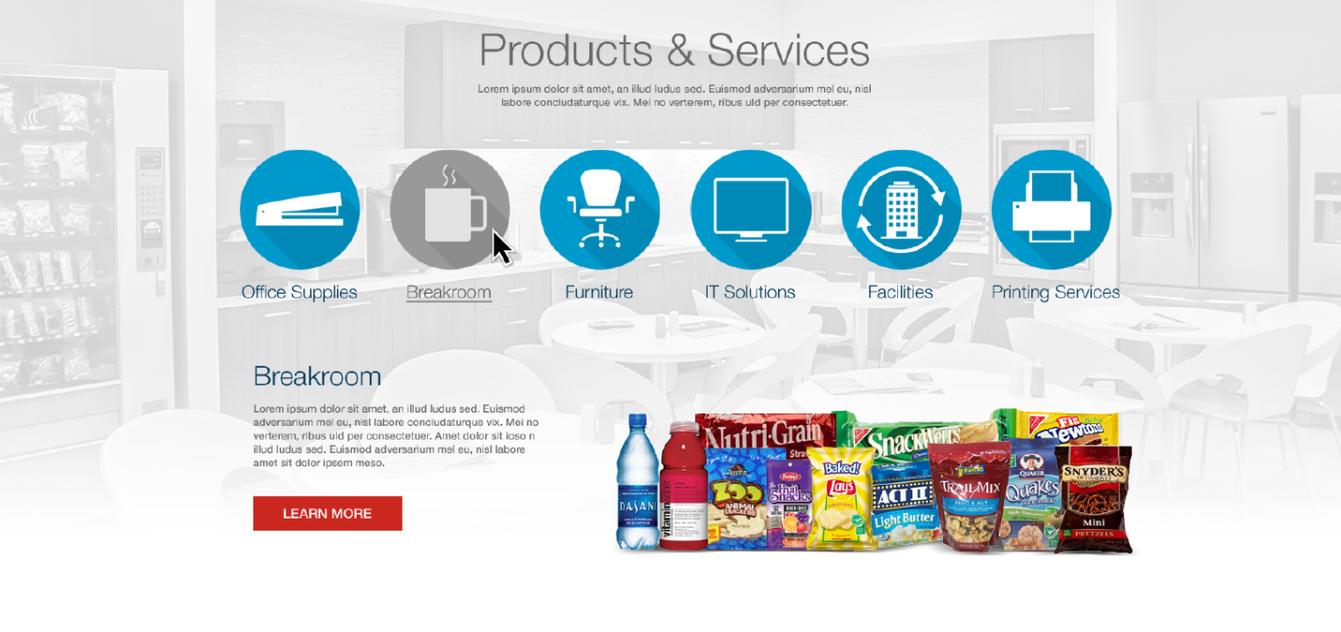

Icon w/ text

Tab Frame

Sub Header

Header

|  |  |  |  |
| --- | --- | --- | --- |
| **Req #** | **Breakpoint** | **Requirement** | **Notes** |
| Products & Services Module | | | |
| 1 | Desktop | Div container consists of header, sub header, background image, a maximum of 8 clickable category icons with clickable text that behaves as a tab system. Each tab frame will be comprised of a title, paragraph, CTA and image. | Each category icon and tab should be created as replicants. Each replicant would include: -Field for div -icon image -icon text field -tab title field -tab description wysiwig -tab CTA with ability to select target window -tab image w/ field for alt text |
| 2 | Desktop | When icon or text is clicked the tab frame text and image coincide with the category clicked. |  |
| 3 | Desktop | There are three states for the category icons: default (blue), rollover (different color), click (different color) | Agency will provide the images for the states |
| 4 | Tablet | Same requirements as desktop |  |
| 5 | Mobile | Contains header, sub header, background image, category icons are a tabular system. Icons are stacked in groups of three and up to eight total icons, corresponding category title, content, image and CTA. Corresponding category image needs to be a set height. | Agency to provide corresponding category image height to dev |
| 6 | Desktop, Tablet, Mobile | Color States – whenever we have a color state of inactive/vs. active, we will need to be able to upload an image. | Back End to have the ability to upload two images. Ability to change the inactive state color. |



Image

Sub Header

Header

|  |  |  |  |
| --- | --- | --- | --- |
| **Req #** | **Breakpoint** | **Requirement** | **Notes** |
| Customer Support Module | | | |
| 1 | Desktop | Div container consists of header, sub header, four images placed in a quadrant formation, each image is clickable and a CTA. On hover a black layer appears over the image which contains text. Each image contains a background image, an icon, a header and paragraph text. | Formatting text controlled using the WYSIWYG (bullets), including CTA and link. Front end to research spans for text area. |
| 2 | Tablet | Same requirements as Desktop excluding on hover action. This will be on tap vs. on hover. | Each quadrant should be created as replicant |
| 3 | Mobile | Displays one section at a time which contains background image, header, sub header, icon which behaves as a carousel with breadcrumbs ( . . . ). There are two states to the breadcrumbs: enabled and disabled. | Agency to provide hexacode for the breadcrumb states |

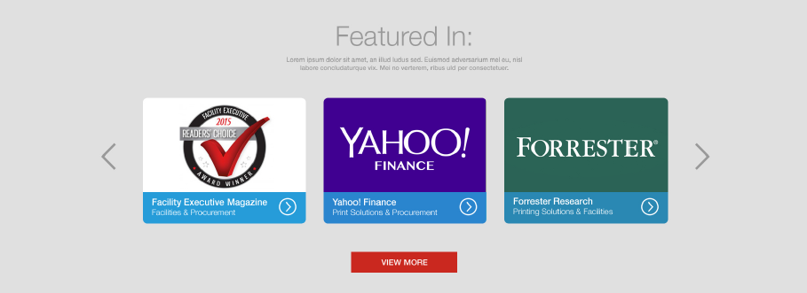

Section which consists of an image, title, description text and an icon

Sub Header

Header

|  |  |  |  |
| --- | --- | --- | --- |
| **Req #** | **Breakpoint** | **Requirement** | **Notes** |
| Media Module | | | |
| 1 | Desktop | Div container consists of header, sub header, carousel with three sections which includes an image, a title, description and an icon. Scrolling navigation with left right carrot arrows. Two states for each section: normal state displays image, title and icon. On hover state the bottom expands to show title, description. Each section is a CTA. | Agency to show comp for hover state.  Each media section should be created as replicants |
| 2 | Tablet | Same requirements as Desktop excluding the hover state. |  |
| 3 | Tablet | Carousel will scroll with finger swipe. |  |
| 4 | Mobile | Same requirements as Tablet excluding hover state. Mobile will display one section at a time with breadcrumbs. Breadcrumbs have two states: enabled and disabled |  |
| 5 | Desktop, Tablet, Mobile | CTA button beneath sections should be optional. |  |